1. 
2. Many collaborators are working on a same git repo.  
   Who made which changes need to be tracked.
3. Commands:
   1. Username and email can be set globally and per project.
   2. These commands would setup username and email only on your local git system.
   3. Username and email can be setup anything you like but  
      it is good practice to match them with those on Github account.
   4. 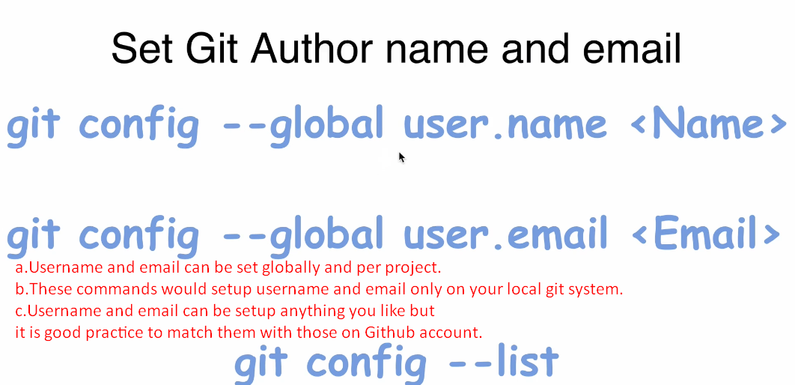
4. 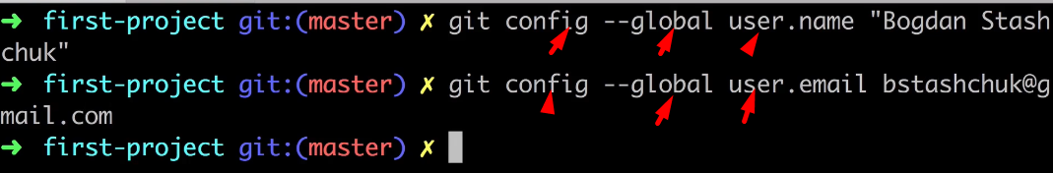  
   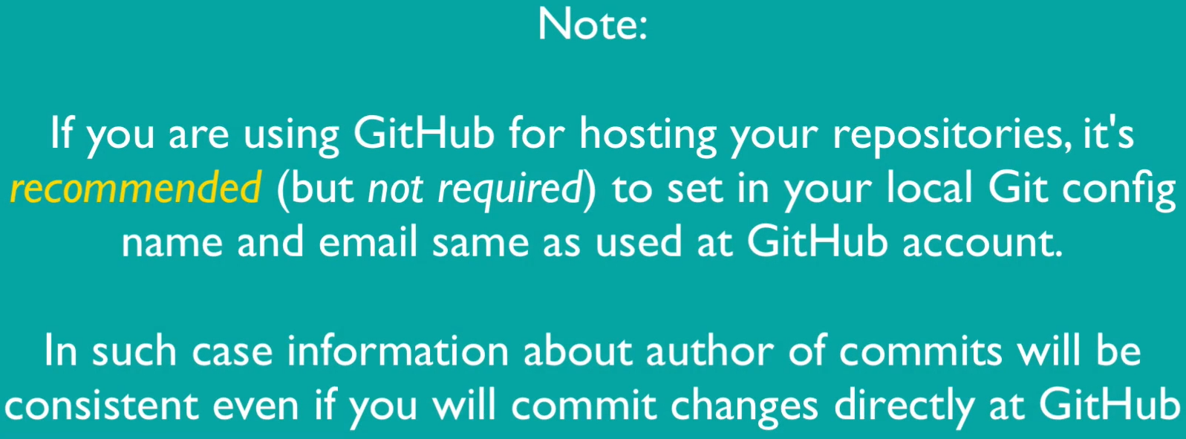
5. 